Hello and welcome to the Fusion tutorial!

We’ll be going over how to download Fusion 360 and set up some basics

# Downloading:

1. Get an account off here: <https://www.autodesk.com/education/edu-software/overview?sorting=featured&page=1&_ga=2.113259271.1654374824.1609034058-835405581.1602797253>
   1. Click the big blackcock“start here” button
   2. May take a few units of time (been pretty scattered; only took like 5 mins for me [maya] but like 8 hours for peeps)
2. Download it here: <https://www.autodesk.com/education/edu-software/overview?sorting=featured&page=1&filters=individual&search=FUSION>

Setting up:

Start up fusion + login

## Teams

Go to the very top right brady bunch button

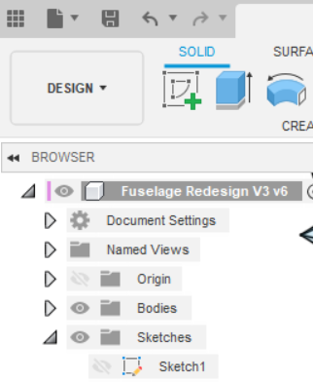--> 

If you don’t see “Flight Club Aerospace” as a team let Maya know asap!!



## Keyboard Shortcuts

Go to anything you want to have a shortcut→ hover for a sec → Change Keyboard shortcut

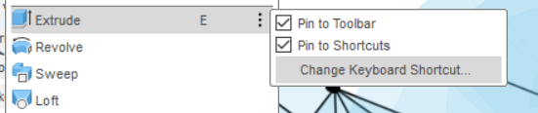

You’ll be using mostly all of the sketch functions, extrude and pipe for FCA

* I would set up all your shortcuts for these

## Preferences

Go to the very top right and click preferences

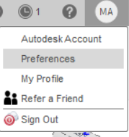

You can click general in the left and change your “pan, zoom, orbit shortcuts” to the software you knew before/ most comfortable with

* I would also change your orbit to free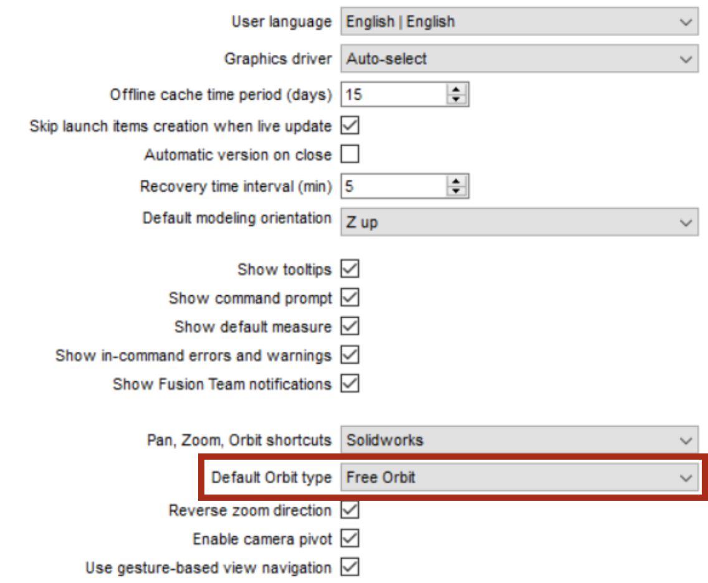
* I’m very bad at solidworks but i’m forcing myself to get used to the controls by using their shortcuts

Go to General>Design and check this box 

Go to Units and Design Units : set everything to imperial (it’ll say “English (in)” or just “in”)

* All our materials (bolts, sheet metal, basically everything) is in imperial that’s why
* Yes we know it’s inferior
* Inches not feet!

Okay sick! You’re ready!

Go to Day 2!